Template for Preparing Manuscript for Journal of Applied Information System and Management (AISM) (Times New Roman 24, Bold, Capitalize Each Word, and Align Center)
First Author¹, Second Author², Third Author³
Abstract—These instructions give you guidelines for preparing papers for Applied Information System and Management journal. Use this document as a template if you are using Microsoft Word 2013 or later. Otherwise, use this document as an instruction set. Please write the Abstract for English or Abstrak in bahasa Indonesia, in one paragraph of 250 words or less. The abstract summarizes the major aspects of the entire paper in a prescribed sequence that includes the research problem; the purpose of the study; the proposed method or basic design; and major findings or trends found as a result of analysis. Please do not cite references in the Abstract.

Index Terms—Enter keywords or phrases separated by commas and at least three words. Please write ‘Kata Kunci’ in Bahasa Indonesia. For example: Information system, UML, computer science, management.

INTRODUCTION
T
his document is a template for Microsoft Word 2013 or later. The introduction describes the objectives of your work and provide an adequate background for readers to understand the paper, the status of knowledge in your field, the question motivating author work and its significance. Also, the introduction describes the significance of proposed method and the support from similar, relevant or previous research. No submission charge should be paid at this stage. We use double-blind system for peer-review; both reviewers and authors’ identities remain anonymous. The paper will be peer-reviewed by two experts. Notification of the result of review is by e-mail.

Related Work
This chapter describes the literature review that supports research, including theory, methods/techniques, models, algorithms, metrics or performance measurements as a reference in conducting research and must refer to journal articles.

Research Method
This chapter describes the proposed or the specific approaches, methods, procedures or techniques used to identify, select, and analyze information applied to understand the research problem/project, thereby, allowing the readers to critically evaluate your project’s/study's overall validity and reliability. The chapter could be consist of some sub sections and indicate as A, B, and etc.

Equations
Number equations consecutively with equation numbers in parentheses flush with the right margin, as in (1). First use the equation editor to create the equation. Use parentheses to avoid ambiguities in denominators. Punctuate equations when they are part of a sentence, as in

(1)

Be sure that the symbols in your equation have been defined before the equation appears or immediately following. Italicize symbols (T might refer to temperature, but T is the unit tesla). Refer to “(1),” not “Eq. (1)” or “equation (1),” except at the beginning of a sentence: “Equation (1) is ... .”

Result
This chapter explains the findings in light of what was already known about the issues being investigated, and to explain any new understanding or insights about the problem after you have taken the findings into consideration. The discussion is written to interpret and describe the significance of the finding. It should connect to the introduction by way of the research questions or hypotheses you posed and the literature you reviewed, but it does not repeat or rearrange the introduction; this section should always explain how your study has moved the reader's understanding of the research problem forward from where you left them at the end of the introduction.
The research findings in the form of research data are further discussed or critically interpreted with particular relevant theoretical approach. State the gap between current research and previous/related research which signifies the significance of your research. Data can also be supported with the presentation of tables, images, etc. Captions for images are placed below the picture, also with providing sequenced numbering. Captions for table is written above it with sequenced numbering so that it can be easily referred to. Some data can be stated in the following sentence.

Color/Grayscale figures

Figures that are meant to appear in color, or shades of black/gray. Such figures may include photographs,
illustrations, multi color graphs, and flowcharts.

Line art figures

Figures that are composed of only black lines and shapes. These figures should have no shades or half-tones of gray. Only black and white.

Author photos

Head and shoulders shots of authors which appear at the end of our papers.

Tables
Data charts which are typically black and white, but sometimes include color.

Conclusion
The conclusion is shorter section which serve two functions. The first is to summarize and bring together the main areas covered in the writing, which might be called ‘looking back’ that intended to answer the research problems or purposes. It helps the readers understand why your research should matter to them after they have finished reading the paper. The second is to give a final comment or judgement on this. The final comment may also include the limitation or constraint of the research and making suggestions or recommend for improvement and speculating on future research/work.
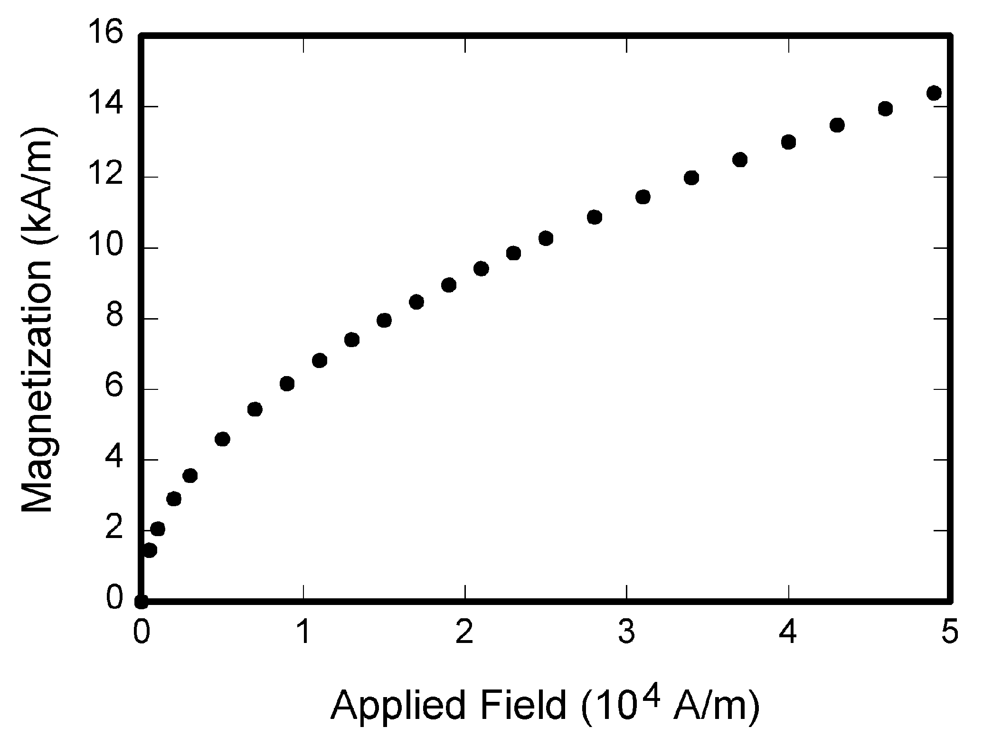
Fig. 1. Magnetization as a function of applied field. Note that “Fig.” is abbreviated. There is a period after the figure number, followed by two spaces. It is good practice to explain the significance of the figure in the caption.

Table 1.
Units for Magnetic Properties
Symbol | Quantity | Conversion from Gaussian and  CGS EMU to SI ª
Φ | magnetic flux | 1 Mx→ 10⁻⁸Wb = 10⁻⁸ V·s
B | magnetic flux density,  magnetic induction | 1 G → 10⁻⁴ T = 10⁻⁴Wb/m²
H | magnetic field strength | 1 Oe→ 10³/(4π) A/m
m | magnetic moment | 1 erg/G = 1 emu  → 10⁻³ A·m² = 10⁻³ J/T
M | magnetization | 1 erg/(G·cm³) = 1 emu/cm³  → 10³ A/m
4πM | magnetization | 1 G → 10³/(4π) A/m
σ | specific magnetization | 1 erg/(G·g) = 1 emu/g → 1 A·m²/kg
j | magnetic dipole  moment | 1 erg/G = 1 emu  → 4π× 10⁻¹⁰Wb·m
J | magnetic polarization | 1 erg/(G·cm³) = 1 emu/cm³  → 4π× 10⁻⁴ T
χ,κ | susceptibility | 1 → 4π
χ_{ρ} | mass susceptibility | 1 cm³/g → 4π× 10⁻³ m³/kg
μ | permeability | 1 → 4π× 10⁻⁷ H/m  = 4π× 10⁻⁷Wb/(A·m)
μ_{r} | relative permeability | μ→μ_{r}
w, W | energy density | 1 erg/cm³→ 10⁻¹ J/m³
N, D | demagnetizing factor | 1 → 1/(4π)
Vertical lines are optional in tables. Statements that serve as captions for the entire table do not need footnote letters.
ªGaussian units are the same as cg emu for magneto statics; Mx = maxwell, G = gauss, Oe = oersted; Wb = weber, V = volt, s = second, T = tesla, m = meter, A = ampere, J = joule, kg = kilogram, H = henry.

Acknowledgment
Acknowledgments enable authors to thank all those who have helped in carrying out the research. Careful thought needs to be given concerning those whose help should be acknowledged and in what order. The general advice is to express your appreciation in a concise manner and to avoid strong emotive language.

References
Reference style refers to the IEEE format - please check the guidelines and make sure to use reference management tool, for instance Mendeley, Zotero, EndNote to follow the preferred style.

Basic format for books:
- J. K. Author, “Title of chapter in the book,” in Title of His Published Book, xth ed. City of Publisher, Country if not USA: Abbrev. of Publisher, year, ch.x, sec. x, pp. xxx–xxx.
Examples:
- G.O.Young,“Synthetic structure of industrial plastics,”in Plastics, 2nd ed., vol. 3, J. Peters, Ed. New York: McGraw-Hill,1964,pp.15–64.
- W.-K.Chen, Linear Networks and Systems. Belmont, CA: Wadsworth, 1993, pp. 123–135.

Basic format for periodicals:
- J. K. Author, “Name of paper,” Abbrev. Title of Periodical, vol. x, no. x, pp. xxx-xxx, Abbrev. Month, year.
Examples:
- J. U. Duncombe, “Infrared navigation—Part I: An assessment
of feasibility,” IEEE Trans. Electron Devices, vol. ED-11, no. 1, pp. 34–39, Jan. 1959.
- E. P. Wigner, “Theory of traveling-wave optical laser,”Phys. Rev.,
vol. 134, pp. A635–A646, Dec. 1965.
- E. H. Miller, “A note on reflector arrays,” IEEE Trans. Antennas Propagat., to be published.

Basic format for reports:
- J. K. Author, “Title of report,” Abbrev. Name of Co., City of Co., Abbrev. State, Rep. xxx, year.
Examples:
- E. E. Reber, R. L. Michell, and C. J. Carter, “Oxygen absorption in the earth’s atmosphere,” Aerospace Corp., Los Angeles, CA, Tech. Rep. TR-0200 (4230-46)-3, Nov. 1988.
- J. H. Davis and J. R. Cogdell, “Calibration program for the 16-foot antenna,” Elect. Eng. Res. Lab., Univ. Texas, Austin, Tech. Memo. NGL-006-69-3, Nov. 15, 1987.

Basic format for handbooks:
- Name of Manual/Handbook, x ed., Abbrev. Name of Co., City of Co., Abbrev. State, year, pp. xxx-xxx.
Examples:
- Transmission Systems for Communications, 3rd ed., Western Electric Co., Winston-Salem, NC, 1985, pp. 44–60.
- Motorola Semiconductor Data Manual, Motorola Semiconductor Products Inc., Phoenix, AZ, 1989.

Basic format for books (when available online):
- Author. (year, month day). Title. (edition) [Type of medium]. volume (issue). Available: site/path/file.
Example:
- J. Jones. (1991, May 10). Networks. (2nd ed.) [Online]. Available: http://www.atm.com

Basic format for journals (when available online):
- Author. (year, month). Title. Journal. [Type of medium]. volume (issue), pages. Available: site/path/file
Example:
- R. J. Vidmar. (1992, Aug.). On the use of atmospheric plasmas as electromagnetic reflectors. IEEE Trans. Plasma Sci. [Online]. 21(3), pp. 876–880. Available:http://www.halcyon.com/pub/journals/21ps03-vidmar

Basic format for papers presented at conferences (when available online):
- Author. (year, month). Title. Presented at Conference title. [Type of Medium]. Available: site/path/file
Example:
- PROCESS Corp., MA. Intranets: Internet technologies deployed behind the firewall for corporate productivity. Presented at
INET 96 Annual Meeting. [Online]. Available:http://home.process.com/Intranets/wp2.htp.

Basic format for reports and handbooks (when available online):
- Author. (year, month). Title. Company. City, State or Country. [Type of Medium]. Available: site/path/file.
Example:
- S. L. Talleen. (1996, Apr.). The Intranet Architecture: Managing information in the new paradigm. Amdahl Corp., CA. [Online]. Available:http://www.amdahl.com/doc/products/bsg/intra/infra/html

Basic format for patents (when available online):
- Name of the invention, by inventor’s name. (year, month day). Patent Number [Type of medium]. Available:site/path/file
Example:
- Musical toothbrush with adjustable neck and mirror, by L.M.R. Brooks. (1992, May 19). Patent D 326 189
[Online]. Available: NEXIS Library: LEXPAT File: DESIGN

Basic format for conference proceedings (published):
- J. K. Author, “Title of paper,” in Abbreviated Name of Conf., City of Conf., Abbrev. State (if given), year, pp. xxxxxx.
Example:
- D. B. Payne and J. R. Stern, “Wavelength-switched passively coupled single-mode optical network,” in Proc. IOOC-ECOC, 1985,
pp.585–590.
Example for papers presented at conferences (unpublished):
- D. Ebehard and E.Voges, “Digital single side band detection for interferometric sensors,” presented at the 2nd Int. Conf. Optical Fiber Sensors, Stuttgart, Germany, Jan.2-5, 1984.

Basic format for patents:
- J. K. Author, “Title of patent,” U.S. Patent x xxx xxx, Abbrev. Month, day, year.
Example:
- G. Brandli and M. Dick, “Alternating current fed power supply,”
U.S.Patent 4 084 217,Nov.4,1978.
Basic format for theses (M.S.) and dissertations (Ph.D):
- J. K. Author, “Title of thesis,” M.S. thesis, Abbrev. Dept., Abbrev. Univ., City of Univ., Abbrev. State, year.
- J. K. Author, “Title of dissertation,” Ph.D. dissertation, Abbrev. Dept., Abbrev. Univ., City of Univ., Abbrev. State,year.
Examples:
- J. O. Williams, “Narrow-band analyzer,” Ph.D. dissertation, Dept. Elect. Eng., Harvard Univ., Cambridge, MA,1993.
- N. Kawasaki, “Parametric study of thermal and chemical non equilibrium nozzle flow,” M.S. thesis, Dept. Electron. Eng., Osaka Univ., Osaka, Japan, 1993.
Basic format for the most common types of unpublished references:
- J. K. Author, private communication, Abbrev. Month, year.
- J. K. Author, “Title of paper,” unpublished.
- J. K. Author, “Title of paper,” to be published.
Examples:
- A. Harrison, private communication, May 1995.
- B. Smith, “An approach to graphs of linear forms,” unpublished.
- A. Brahms, “Representation error for real numbers in binary computer arithmetic,” IEEE Computer Group Repository, Paper R-67-85.

Basic format for standards:
- Title of Standard, Standard number, date.
Examples:
- IEEE Criteria for Class IE Electric Systems, IEEE Standard 308, 1969.
- Letter Symbols for Quantities, ANSI Standard Y10.5-1968.

______________________________________________________________This paragraph of the first footnote will contain the date on which you submitted your paper for review, revised, and accepted. ¹S. B. Author, UIN Syarif Hidayatullah Jakarta Indonesia (e-mail: author@uinjkt.ac.id). ²T. C. Author, Electrical Engineering Department, University of Indonesia (e-mail: author@ui.ac.id).

